신채운/202135789

## STEP 1: understand the problem (requirements analysis)

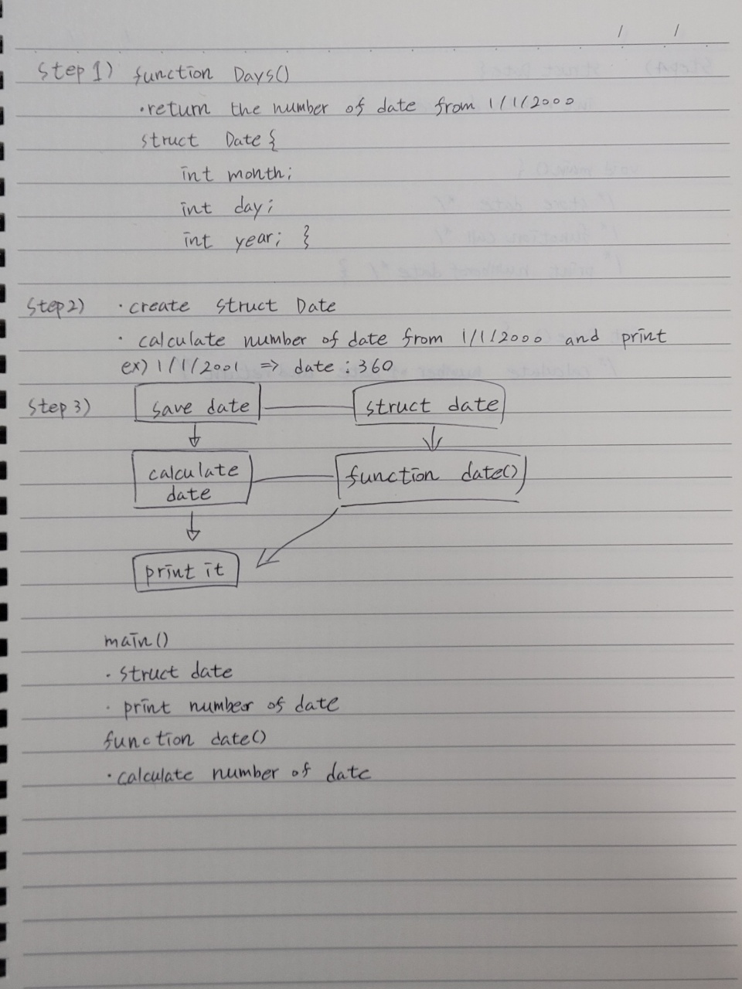

## STEP 2: outline a solution (basic design)



## STEP 3: form a program structure (basic design)



## STEP 4: write a program outline (pseudo code)

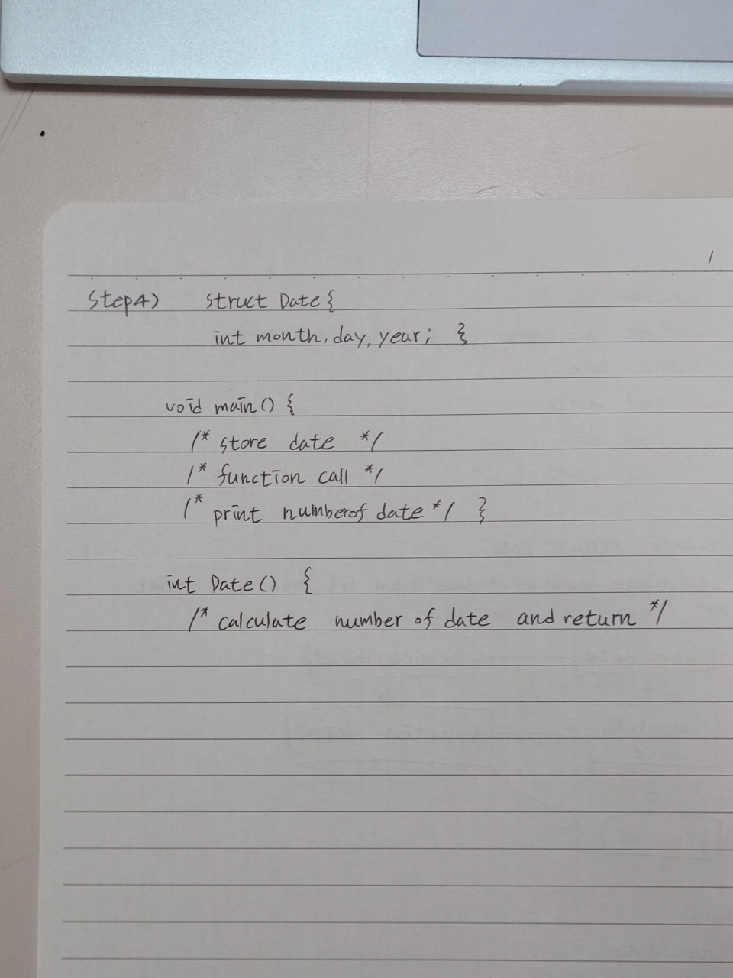

## Source codes & Comment

// 아래 네모 안에 코드를 복사하여 붙일 것

|  |
| --- |
| #include <stdio.h>  /**  file name : Exercise 12.3 1  author : 202135789 신채운  date : 9 / 30  Course : Problem Solving Methods  description :  1 Year=360 days  1 month=30 days  function should return the number of days from 1/1/2000  */  struct Date {  int month;  int day;  int year;  };  int Days(int, int, int);  void main() {  struct Date Date;  printf("Please type month: "); //store date  scanf_s("%d", &Date.month);  printf("Please type day: ");  scanf_s("%d", &Date.day);  printf("Please type year: ");  scanf_s("%d", &Date.year);  printf("\nToday is %d/%d/%d", Date.month, Date.day, Date.year);  printf("\nNumber of days: %d", Days(Date.month - 1, Date.day - 1, Date.year - 2000));  }  int Days(int month, int day, int year) { //function for calculate days  int sum = 0;  sum = sum + month * 30;  sum = sum + day;  sum = sum + year * 360;  return sum;  } |

## Inspect the program (testing)

// 자가 점검 후 네모 안에 v표시

🗹 Check loop, if else, switch, function.

🗹 Check variable initialization.

🗹 Check pointers.

## Test cases & Output (Screenshots)

|  |  |
| --- | --- |
| # | Input:9/30/2021 |
|  | |